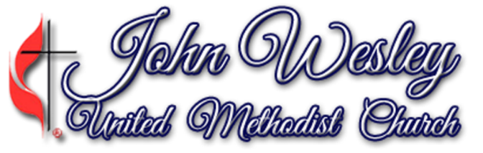

901 Benton Avenue, Nashville, TN 37204
Rev. Daniel M. Hayes Sr., Senior Pastor/Teacher

Safe Sanctuaries Guidelines – WORK IN PROGRESS
2014 Charge Conference

Policy Statement
God calls us to make our churches safe places, protecting children and other vulnerable persons from abuse. The intent of our Safe Sanctuaries policy for John Wesley United Methodist Church is to prevent child abuse in our local church and to protect our church, our staff and clergy from allegations of improper conduct. Further, the policy is intended to provide requirements for laity, clergy, lay employees and volunteers of John Wesley United Methodist Church. The implementation of these policies and operating procedures must respond to the expectation that children must be protected from economic, physical, emotional, and sexual exploitation and abuse.
Purpose
We must be committed to providing a safe and secure environment for all children, youth and adults who participate in ministries and activities sponsored by our church. These policies and operating guidelines will require that all adult clergy, staff and volunteers working with children and youth be trained in understanding and conformity to those policies and guidelines.
Safe Sanctuaries procedures we may implement:
- Two-Adult rule: two unrelated adults in all activities with children and youth
- Roving Monitor during ministry and class times
- Open door or windows in all classroom doors
- Five Year older rule: all leaders 5 years older than the oldest participant
- No workers/volunteers with children/youth under 18 without adult present
- Six-month membership rule before working with children
- Individuals who have been convicted of any crime against a child or teenager will not be accepted as a worker with children or youth
- Bathroom procedures for children and youth: children under five should be escorted to the bathroom. A buddy system for children should be practice.
- Annual training in Safe Sanctuaries Policy an Operations and “first aid” and “CPR”, for every adult volunteer or employee interacting with children. (Local FD, Red Cross, Health Dept).
If abuse is alleged to have occurred at a John Wesley event or on church property, the following steps should be taken by the pastor and any other appointed persons.
- Notify parents of victims and assure the victim’s safety.
- Treat the alleged abuser with dignity, not anger and remove him/her from further involvement with youth.
- Report the alleged abuse to the local child abuse services or local police.
- Notify the District Superintendent, the church’s attorney and the church’s insurance agent.
- Do not speak with the media.
- Keep a written record of the steps taken by the church in response to allegations of abuse.
- The Pastor or District Superintendent will handle notification of the congregation as appropriate.
Guidelines for protecting our elderly and other vulnerable communities are in the developmental stage. Ensuring building safety, facility updates for preventing slips, trips and falls, and implementing an emergency plan, will be addressed as this document evolves.
Prayerfully submitted,
Shiela Hayes-Greer
Trustee Ministry

John Wesley United Methodist Church
Safe Sanctuaries Guidelines
This document is a work-in-progress. Additional work in underway to develop a more inclusive document.

I. Policy Statement
II. Purpose
III. Our Covenant
IV. Procedures (Basic/General)
V. Procedures Specific to children
VI. Procedures for reporting incidents of abuse
VII. Responding to allegations of abuse

